Project Design Phase-II
Data Flow Diagram & User Stories
Date | 15/07/2026
Team ID | SWTID-2026-3548
Project Name | Personalized Networking Assistant
Maximum Marks

Data Flow Diagrams
A Data Flow Diagram (DFD) is a structured visual representation of how information moves through the Personalized Networking Assistant system. It illustrates how event descriptions and user interests enter the system, how the data is transformed by the theme extraction, fact verification, and conversation starter generation modules, and where the resulting data is stored or returned to the user. The following diagrams describe the system at two levels of detail: a Level 0 context diagram and a Level 1 detailed process diagram.
Level 0 DFD – Context Diagram
The Level 0 diagram represents the Personalized Networking Assistant as a single process interacting with two external entities: the User, who supplies event descriptions, personal interests, and feedback, and the Wikipedia API, which is queried to verify facts used in generated conversation starters. The system returns personalized, fact-checked conversation starters to the user.
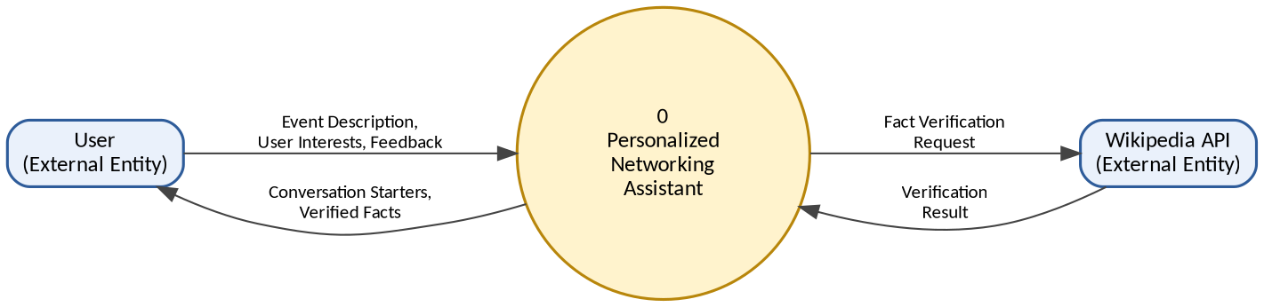
Figure 1: Level 0 DFD – Context Diagram of the Personalized Networking Assistant
Level 1 DFD – Detailed Process Diagram
The Level 1 diagram decomposes the system into its core processing modules. User input is first cleaned and structured (1.0), after which key themes are extracted using DistilBERT (2.0). Extracted themes are verified against the Wikipedia API for factual accuracy (3.0), and verified information is used to generate personalized conversation starters using GPT-2 (4.0). Generated conversation starters are stored in the History Database (D1) and returned to the user, while user feedback on the generated starters is captured and stored in the Feedback Database (D2) through the feedback logging process (5.0).
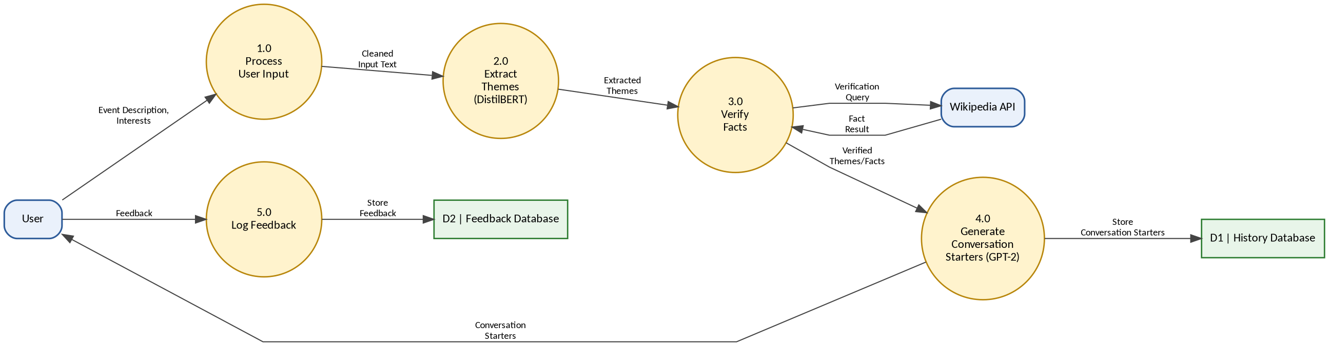
Figure 2: Level 1 DFD – Detailed Process Diagram of the Personalized Networking Assistant

User Stories
The table below lists the user stories for the Personalized Networking Assistant, derived directly from the implemented features of the system. Each user story is mapped to a functional requirement (epic), assigned a unique identifier, acceptance criteria, priority level, and release sprint.
User Type | Functional Requirement (Epic) | User Story Number | User Story / Task | Acceptance Criteria | Priority | Release
User | User Interest Input | USN-1 | As a user, I can enter my interests, profession, and background so the system can personalize conversation starters for me. | User interests are captured and saved for the current session. | High | Sprint-1
 | Event Description Input | USN-2 | As a user, I can enter or paste an event description so the system can analyze its context. | Event description is accepted and passed to the theme extraction module. | High | Sprint-1
 | Theme Extraction | USN-3 | As a user, I want the system to automatically identify key themes from the event description using DistilBERT. | Extracted themes are displayed to the user before starter generation. | High | Sprint-1
 | Conversation Starter Generation | USN-4 | As a user, I can generate personalized networking conversation starters based on my interests and the event context. | At least three relevant conversation starters are generated using GPT-2. | High | Sprint-2
 |  | USN-5 | As a user, I can regenerate conversation starters if I am not satisfied with the current suggestions. | New set of conversation starters is generated on request. | Medium | Sprint-2
 | Fact Verification | USN-6 | As a user, I want the facts used in conversation starters to be verified through the Wikipedia API for accuracy. | Verified facts are marked and displayed alongside the conversation starter. | Medium | Sprint-2
 | History Logging | USN-7 | As a user, I can view my previously generated conversation starters from the history log. | Past conversation starters are retrieved from the SQLite database and displayed. | Medium | Sprint-3
 | Feedback Logging | USN-8 | As a user, I can provide feedback (helpful / not helpful) on a generated conversation starter. | Feedback is stored in the database and linked to the corresponding starter. | Low | Sprint-3
 | Web Interface | USN-9 | As a user, I can access all features through a simple and interactive Streamlit web interface. | All core features are accessible without requiring technical knowledge. | High | Sprint-1
Administrator | System Monitoring | USN-10 | As an administrator, I can monitor API requests and system logs to ensure the backend services are functioning correctly. | Backend logs and REST API responses are accessible for review. | Low | Sprint-3
 | Testing & Quality Assurance | USN-11 | As an administrator, I can run unit tests using pytest to validate the correctness of backend modules. | All backend modules pass the defined pytest test cases. | Medium | Sprint-3

